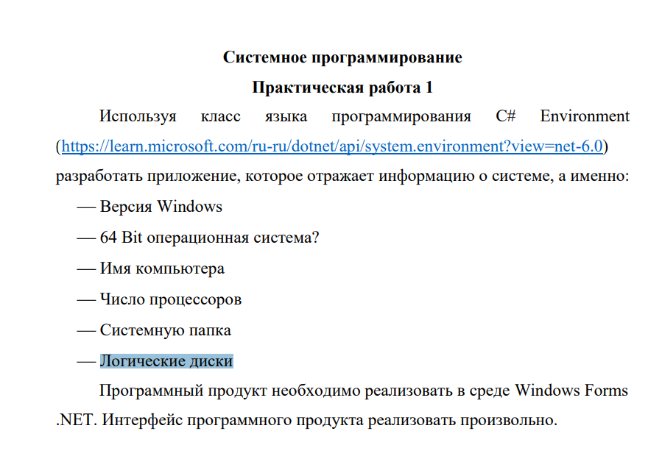

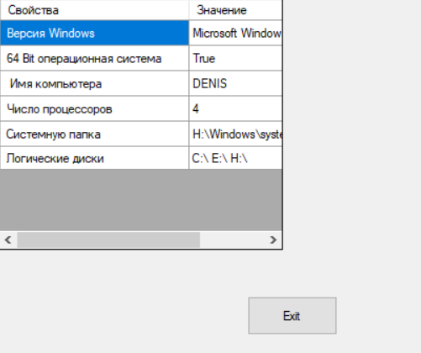

using System;

using System.Collections.Generic;

using System.ComponentModel;

using System.Data;

using System.Drawing;

using System.Linq;

using System.Text;

using System.Threading.Tasks;

using System.Windows.Forms;

namespace WindowsFormsApp1

{

public partial class Form1 : Form

{

public Form1()

{

InitializeComponent();

}

private void dataGridView1_CellContentClick(object sender, DataGridViewCellEventArgs e)

{

}

private void button1_Click(object sender, EventArgs e)

{

Environment.Exit(0);

}

private void Form1_Load(object sender, EventArgs e)

{

dataGridView1.RowCount = 6;

dataGridView1[0, 0].Value = " Версия Windows";

dataGridView1[0, 1].Value = " 64 Bit операционная система";

dataGridView1[0, 2].Value = " Имя компьютера";

dataGridView1[0, 3].Value = " Число процессоров";

dataGridView1[0, 4].Value = " Системную папка";

dataGridView1[0, 5].Value = " Логические диски";

dataGridView1[1, 0].Value =Environment.OSVersion.ToString();

dataGridView1[1, 1].Value = Environment.Is64BitOperatingSystem.ToString();

dataGridView1[1, 2].Value = Environment.MachineName.ToString();

dataGridView1[1, 3].Value = Environment.ProcessorCount.ToString();

dataGridView1[1, 4].Value = Environment.SystemDirectory.ToString();

string [] s = Environment.GetLogicalDrives();

string str = "";

for (int i = 0; i < s.Length; i++)

{

str += s[i] + " ";

}

dataGridView1[1, 5].Value = str;

}

}

}